Secure password manager, Pass Wizard, now 50% off with promo code PRO50
BELLEVUE, Washington Dec. 1, 2022 – Pacific Software Publishing Inc. (PSPINC) launches a 50% off sale for the Pro plan of their password management tool, Pass Wizard. Pass Wizard is a cloud-based password manager with the option to store as many passwords as a user would like, and share select passwords within a group they create.
According to Microsoft’s Digital Defense Report from 2022, there has been a 74% increase of password attacks compared to last year. And research predicts the trend will continue to rise as it’s become a cybercriminal’s primary method of obtaining a person’s identity. Utilizing a secure password manager significantly reduces the risk of these types of attacks and serves as the first line of defense to protect users’ accounts.
With Pass Wizard’s paid plan, Pass Wizard Pro, users can:
- Store an unlimited number of passwords
- Create shared passwords
- Add group members to your account
- Share select passwords with other users within their group
PSPINC created Pass Wizard to make it easier for users to keep their account information safe while using the internet. Designed in-house and developed with state-of-the-art systems, Pass Wizard allows small business owners and managers a secure way to share specific confidential login credentials with the Pro plan. Group plans with Pass Wizard Pro also eliminate the worry of potential security breaches when sharing sensitive data amongst an organization.
Pass Wizard Pro is currently 50% off with the promo code, PRO50, making it the most affordable password manager on the market.
For more information, please contact Pacific Software Publishing Inc. at 1-800-232-3989 or by email at contact@pspinc.com.
Source: https://www.pspinc.com/pass-wizard

Screenshots:

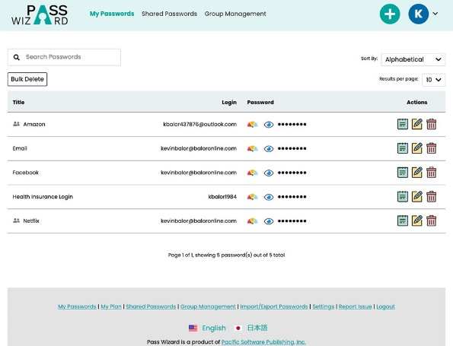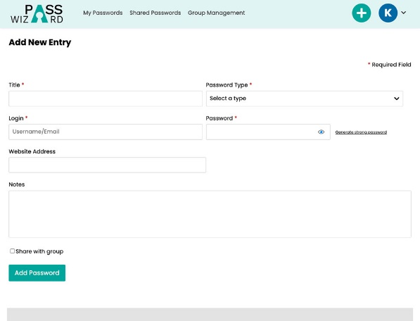
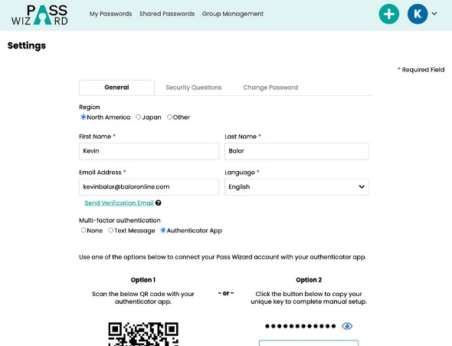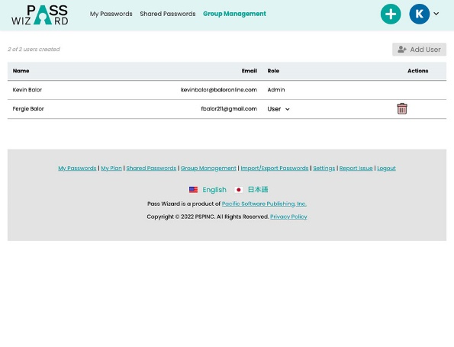
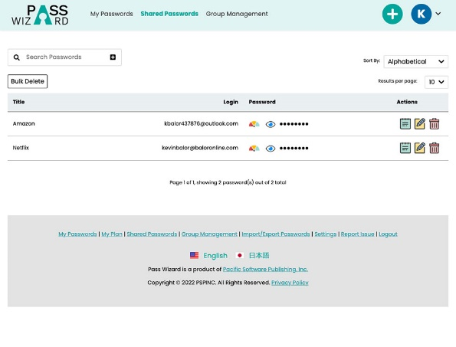

About Pacific Software Publishing Inc.
Pacific Software Publishing, Inc. is an independent software development company committed to helping small businesses grow online. First established in 1987, PSPINC now serves more than 40,000 companies of all sizes around the world with software designed and developed in-house to help businesses thrive online.

Contact:
Ken Uchikura | Founder / CEO
Pacific Software Publishing Inc.
425-957-0808
contact@pspinc.com
https://www.pspinc.com

